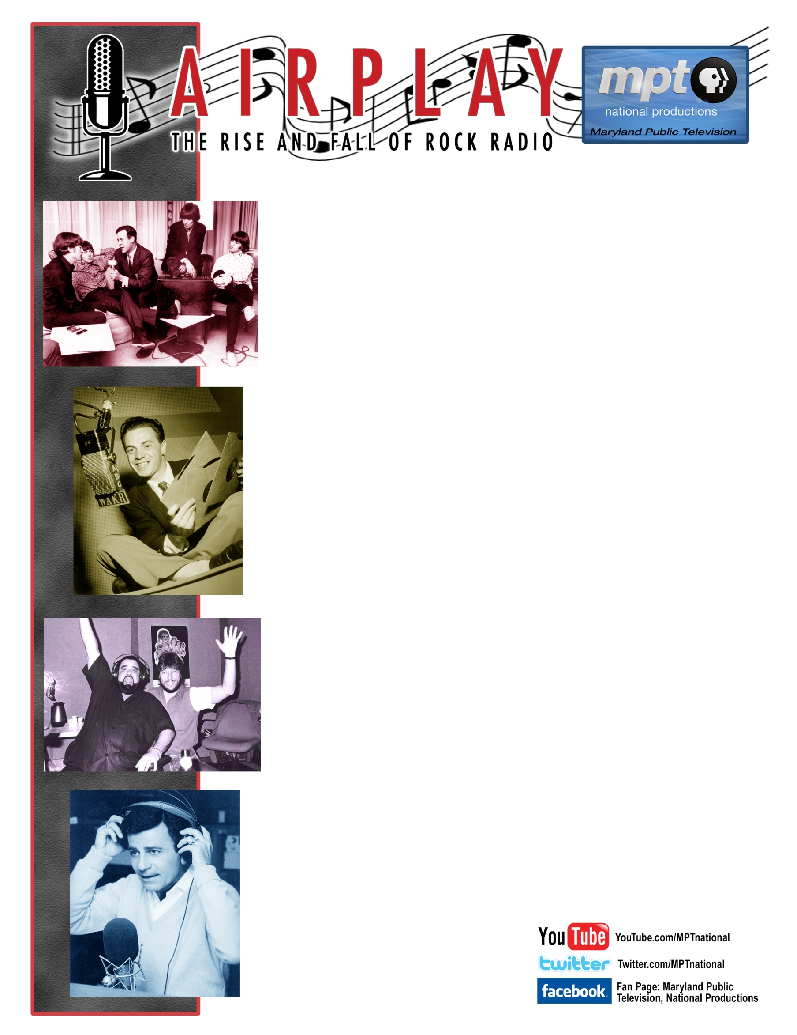

**NON-PLEDGE PROGRAM VERSION RELEASING ON OCTOBER 4, 2011**

If you want to understand how America works, look at what happened to Rock radio. For 50 years, it was our revolutionary medium. Radio had the power to move people then… and deejays seized it. In the 1950s, a handful of pioneers introduced White America to Black R & B. While New York deejay Alan Freed changed the course of American culture by branding it “rock ‘n’ roll.”

In its glory years, personalities like Cousin Brucie, Murray the K, Dan Ingram, Jerry Blavat, Casey Kasem, Dick Biondi and Wolfman Jack ruled the airwaves… but Rock Radio always had powerful enemies. Congress held “payola” hearings to target the personalities breaking down racial and economic barriers… and Alan Freed got booted off the air.

***Airplay: The Rise and Fall of Rock Radio*** documents the history, from the AM jocks who blasted Black music to White America and named it 'Rock 'n Roll', to the FM pioneers who fanned the flames of the 60s, to the silencing of rock radio as we knew it by government meddling and big business mediocrity, to its promise of rebirth on satellite radio.

*Airplay* is the story of the 50-year struggle for the soul of music radio, told by the deejays and the artists they made stars. Musicians including Crosby, Stills and Nash, Grace Slick, Little Steven Van Zandt, Bob Weir (Grateful Dead, Ratdog) and Ray Manzarek (Doors) and legendary disc jockeys from AM and FM talk about the hits and the history they made together in live interviews, archival footage and airchecks… some seen and heard on television for the first time.

*This* ***90-minute Base Version*** *of the program contains footage and interviews that were not included in the pledge version that was released earlier this year.*

For more information:

**Phillip Guthrie**

**Director of Station Relations**

**Maryland Public Television**

**pguthrie@mpt.org**

**410.581.4187**

