THINKING MONEY: THE PSYCHOLOGY BEHIND
OUR BEST AND WORST FINANCIAL DECISIONS
Launches October 16, 2014 on Public Television Stations

— Why is it so much more fun to spend than save? Can we re-wire our brains to make smarter financial decisions? —

If you’ve ever made a financial decision you regretted the next day, you’re not alone. In fact, as the emerging field of behavioral economics reveals, you’re practically hard-wired to overspend, an activity that lights up the brain’s pleasure centers.

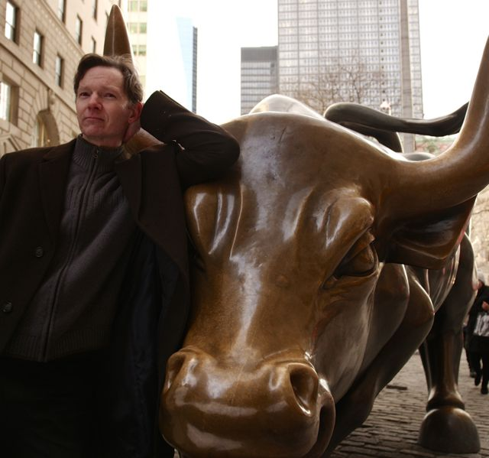
Host Dave Coyne.
Credit: Rocket Media Group

Thinking Money: The Psychology Behind Our Best and Worst Financial Decisions uses a mix of humor, on-the-street interviews and provocative insights from innovative thinkers to explore why we spend, why we save (or don’t), and how we think about money. Host Dave Coyne travels from Wall Street to Main Street, and from Yale to the Santa Barbara wine country, to find out how our brains — and the marketplace — maneuver to get us to spend money we shouldn’t. A mix of fascinating theory and practical takeaways, Thinking Money releases to public television stations on October 16, 2014 (check local listings for air times).

Behavioral economists have found we all have a natural desire to buy things even though our long-term futures depend on saving, not spending. An unrealistic optimism about our future wealth — a bias towards overconfidence — combined with an illusion of invulnerability make us not just poor savers, but more susceptible to fraud and risky investments. In the documentary, we learn these natural biases tend to affect us most when we are dealing with complex, long-term decisions.

Time after time our emotional brain triumphs over our rational brain, a fact we can blame on our biology. “The rational brain simply rationalizes what the emotional brain has already decided to do,” says noted Stanford neuroeconomist Dr. Baba Shiv. “The only long-term solution for this is to make saving more sexy . . . for the brain.”

Thinking Money explores an array of challenging ideas and findings that have profound implications for our financial behavior, including:

* How Americans’ increasing financial fragility has led to an explosion of “downmarket” and even predatory sources of credit. There are now more payday loan stores in America than all the McDonald’s, Starbucks and Targets combined;

* Why too many choices can be paralyzing when it comes to small decisions, and big ones;

* How having a good “nudge” — especially one with an unpleasant consequence attached to it — can help you achieve your financial goals;

* In what way “confirmation bias,” the tendency for us to search for evidence that confirms what we already believe and disregard evidence that doesn’t, impacts our financial decisions; and

* How employers are using “choice architecture” and “the power of defaults” to help us put money into savings.

Fascinating experiments provide insights into the way our brains influence our behavior. A horizontal wine tasting in a Cal Tech fMRI machine reveals that our brains are intoxicated by price — the more we think something costs, the better we like it. Two tables of jam bottles in a supermarket show that customers are initially attracted to a wide variety of choices, but are more likely to actually purchase when offered fewer options. And, in a Stanford virtual reality lab, a startled Dave Coyne gets to “meet” an older version of himself in an experiment designed to overcome our procrastination by creating empathy for the retirees we will eventually become — and for whom we need to be saving today.

Is changing our behavior a lost cause? Can we override our emotional brains and be more financially responsible? Startups all over the country are developing innovative ways to make saving, if not exactly sexy, at least easier and more appealing. Coyne visits with the founder of a New York startup that creates “commitment contracts” to help savers meet their goals — and forfeits your money to organizations you despise if you don’t. The documentary also highlights other websites and apps that are using the latest psychological findings about our spending habits to guide us toward saving.

Thinking Money not only illuminates the way our brains work, but offers real solutions to get us on the path to financial security.

For broadcast information, viewers can check local listings, or contact their local Public Television Station about Thinking Money. Public TV stations can be located through this online station finder: APT Station Finder.

Thinking Money is produced by Rocket Media Group, LLC in association with the FINRA Investor Education Foundation and Maryland Public Television. It is shot in 4k on the RED Epic camera. Director of Photography is Stefan Wiesen. Rocket’s founding partners, Ward LeHardy and Tom Feliu, are executive producer and director of the documentary. John Greco is the writer and producer. The program is distributed nationally by American Public Television (APT).

About the Participants, in Order of Appearance:

Eldar Shafir is a professor of Psychology and Public Affairs at Princeton University and the co-author of Scarcity: Why Having So Little Means So Much.

Annamaria Lusardi is the Denit Trust Chair of Economics and Accountancy at the George Washington University School of Business. She is the co-author of Financial Literacy: Implications for Retirement Security and the Financial Marketplace and author of Overcoming the Saving Slump: How to Increase the Effectiveness of Financial Education and Saving Programs.

David Adame is manager of Crossroads Pawn, Falls Church, VA.

Baba Shiv is a neuroeconomist and Professor of Marketing at Stanford University’s Graduate School of Business.

Hilke Plassmann is Assistant Professor of Marketing at INSEAD, France.

Daylian Cain is Assistant Professor of Organizational Behavior at Yale University School of Management.

Doug Shadel is a former fraud investigator and national expert on financial fraud who is now state director for AARP Washington.

Sheena Iyengar is the S.T. Lee Professor of Business in the Management Division of the Columbia Business School and author of The Art of Choosing.

Gerri Walsh is President of the FINRA (Financial Industry Regulatory Authority) Investor Education Foundation.

Lori Schock is the Director of the Office of Investor Education and Advocacy for the US Securities and Exchange Commission (SEC).

Hal Hershfield is Assistant Professor of Marketing, UCLA School of Business.

Jordan Goldberg is CEO of stickK, an online commitment contract service.

Graham Browne is a graduate student and stickK contract client.

Jonathan Zinman is Professor of Economics at Dartmouth University and on the advisory board of Hello Wallet.

About Rocket Media
Rocket Media Group, LLC is a Washington, DC-area Emmy Award winning production company. Director Tom Feliu and Executive Producer Ward LeHardy are the principals at Rocket. For Thinking Money, they have teamed with former Dateline NBC producer John Greco to write and produce the documentary.

About FINRA Investor Education Foundation
The FINRA Investor Education Foundation supports innovative research and educational projects that give underserved Americans the knowledge, skills and tools necessary for financial success throughout life. For details about FINRA Foundation initiatives, visit www.finrafoundation.org.

About MPT
Launched in 1969 and headquartered in Owings Mills, MD, Maryland Public Television is a nonprofit, state-licensed public television network and member of the Public Broadcasting Service (PBS). MPT’s six transmitters cover Maryland plus portions of contiguous states and the District of Columbia. Frequent winner of regional Emmy® awards, MPT creates local, regional, and national television shows. Beyond broadcast, MPT’s commitment to professional educators, parents, caregivers, and learners of all ages is delivered through year-round instructional events and the super-website Thinkport, which garners in excess of 19 million page views annually. MPT’s community engagement connects viewers with local resources on significant health, education, and public interest topics through year-round outreach events, viewer forums, program screenings, and phone bank call-in opportunities.

* * *
Contact:

CaraMar Publicity
Mary Lugo 770-623-8190 lugo@negia.net
Cara White 843-881-1480 cara.white@mac.com
Abbe Harris 908-233-7990 abbe@caramar.net

For more information and photos: Thinking Money press materials.

