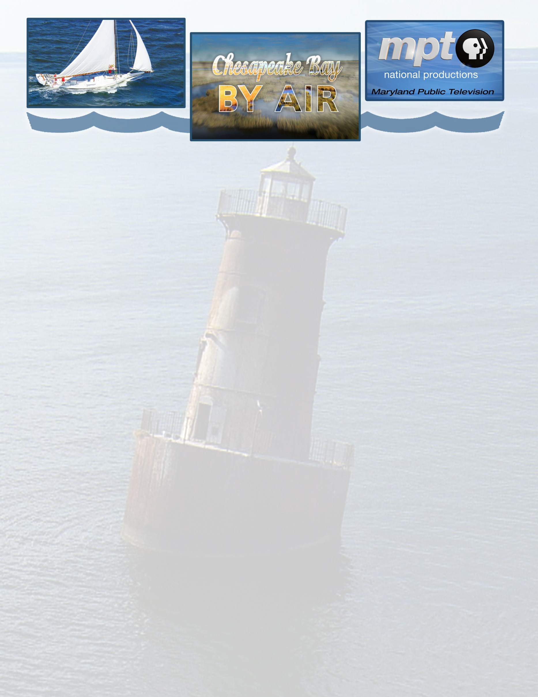

Program Title: Chesapeake Bay By Air

Distributed by: American Public Television
Pledge Length: 1/60 Base Version

HD NOLA: CBBA 000 HD-Pledge Event Revision 001
HD Feed: Monday, September 5 @ 2000 – 2100 ET HD-03

Closed Captioned: Yes
Stereo: HD - 5.1 Surround/SD - Stereo
SAP: No
Format/Version: 1/60 Base Version HD
Aspect ratio: HD 1080i
Suggested TV Rating: TV-G

Description: Chesapeake Bay By Air forever captures the unparalleled wild beauty, history and natural serenity of the bay. Shot by helicopter at heights from two to two thousand feet using state-of-the-art High Definition recording gear, Chesapeake Bay By Air’s unique perspective of the Chesapeake Bay marries gentle verse, prose and music with stunningly dramatic images of the Chesapeake in a way that, until now, only migrating Canada Geese could truly appreciate. Chesapeake Bay By Air’s meandering aerial journey transports viewers to many of the Chesapeake Bay’s countless stunning locations -- from a purple-orange dawn over the Susquehanna River to the mystery of the carved marsh of Blackwater Wildlife Refuge… from the tranquil fishing village of Smith Island to the belching smokestacks of Sparrow’s Point… from ancient Calvert Cliffs to bustling small-city Annapolis and metropolis Baltimore… and from the mighty steel spans of the Chesapeake Bay Bridges and then to historic Point Lookout, Chesapeake Bay By Air brings the bay into razor-sharp perspective.

Suggested Scheduling: Evenings, Daytimes, Weekends, Around other Environmental Programs

Broadcast History: Standard Version National Broadcast Premiere. MPT broadcast and offered to markets surrounding the Chesapeake Bay in April 2010, and in March 2011, offered a national pledge version which is still in rights through 2013.

Rights: Unlimited releases over 2 years beginning with feed; School rights: 1 year; non-commercial cable rights granted; V.O.D. rights granted for free VOD only.
Flags: None

Producer: Maryland Public Television

Date Produced: 2010

Underwriting: Local underwriting permitted
Web Site: chesapeakebaybyair.org

Viewer Contact: MPT Viewer Services, viewerservices@mpt.org
Phone: 410-581-4097 or TDD 1-800-627-6788

Station Relations Contact: Phillip Guthrie Director of Station Relations
pguthrie@mpt.org 410.581.4187

Releases, Photos, Bios, etc: Station Toolkit: www.mpt.org/stationrelations Password: Station

