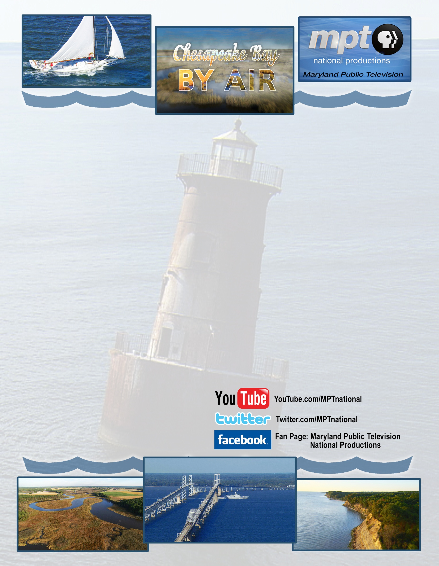
Experience a Breathtaking Aerial Journey
Across the Chesapeake Bay Region
Non-pledge Version Releasing on September 5, 2011

From the wild beauty of meandering creeks and rivers… to the dramatic allure of Calvert Cliffs… from lonely lighthouses… to the bustle of Annapolis and the power of the mighty Susquehanna… Chesapeake Bay By Air is a soaring look at the sites and attractions throughout the Chesapeake Bay Region presented in amazing High Definition.
The program opens from the sky and swoops down over famous Chesapeake-area landmarks, such as: St. Michaels, the Chesapeake Bay Bridge, Annapolis and the Baltimore Harbor. Viewers will marvel at the Chesapeake Bay in all its glory - in spring, summer and fall - as we touch the history, excitement, natural beauty and appeal of the Chesapeake region and all it has to offer.
Other highlights also include: Smith Island; Crisfield; St. Mary’s City; the Blackwater Wildlife Refuge; Calvert Cliffs; Tilghman Island; Kent Island; Baltimore Light; the Port of Baltimore; Gunpowder River; the Potomac, Chesapeake and Delaware Canal and more.
DVD & Blu-ray discs are available of this incredible journey. Both the DVD and Blu-ray versions include a bonus program: The Skipjacks - a look back at the legendary Skipjack fleet that once plied the waters of Chesapeake Bay in search of the Chesapeake oyster.

For more information:

Phillip Guthrie
Director – Station Relations
Maryland Public Television
pguthrie@mpt.org 410.581.4187
SR Website: www.mpt.org/stationrelations
password: station

