

July xx, 2017

234 West 44th Street

New York City, 10036

212-764-7900

FAX 764-0344

www.ksa-pr.com

***FOR IMMEDIATE RELEASE***

*Press contact: Scott Klein at Keith Sherman & Associates,* [*scott@ksa-pr.com*](mailto:scott@ksa-pr.com)*, 212-764-7900*

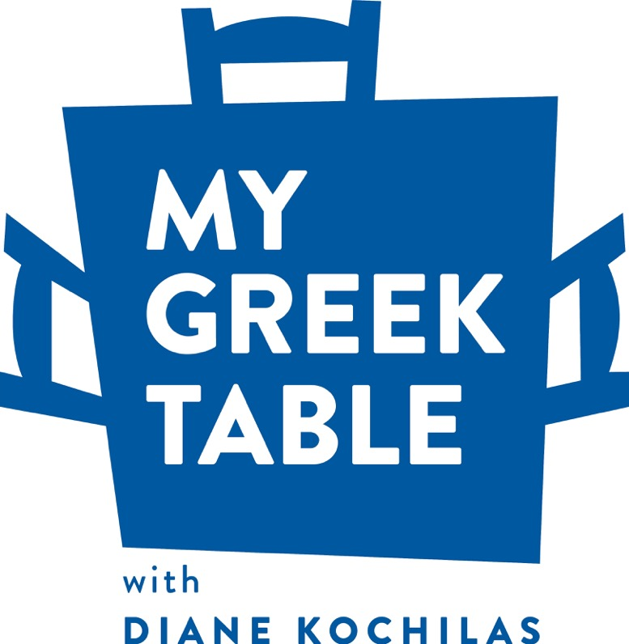

**AWARD-WINNING AUTHOR OF**

**OVER 10 COOKBOOKS, TELEVISION HOST, CONSULTING CHEF, AND**

**GREEK FOOD EXPERT**

**DIANE KOCHILAS**

**TO DEBUT HER NEW**

**PUBLIC TELEVISION SERIES**

**ON GREEK CUISINE**

**MY GREEK TABLE WITH DIANE KOCHILAS**

[**www.DianeKochilas.com**](http://www.DianeKochilas.com)

**PREMIERES ON PUBLIC TELEVISION OCTOBER 6**

OPA!

Travel to Greece and taste its delicacies…without ever leaving your living room.

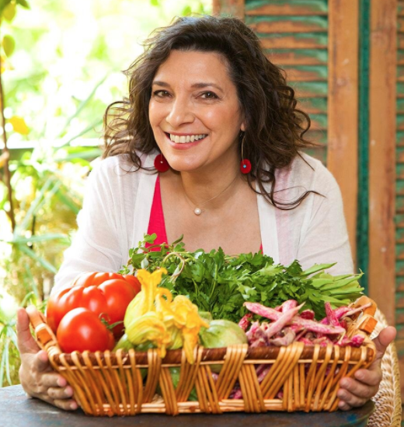

**Diane Kochilas**, award-winning cookbook author, television personality, consulting chef, teacher, and one of the world’s foremost authorities on Greek cuisine, will launch her delectable cooking program this October –

**“My Greek Table With Diane Kochilas”** ([www.DianeKochilas.com](http://www.DianeKochilas.com)).

Premiering October 6 on public television stations across the country (check local listings) with 13 amazing episodes, the seriestakes viewers to the source, as Diane introduces the stunning vistas, fabulous food, easy, nutritious recipes, and the unmatched hospitality Greece is known for worldwide.

To celebrate the launch of the television series, St. Martin’s Press will re-release Diane’s first book The Food and Wine of Greece.

What makes “**My Greek Table With Diane Kochilas”**special?

* **A passionate host with international appeal**: One of the world’s foremost authorities on Greek cuisine, native New Yorker Diane Kochilas hosted one of Greece’s most popular cooking shows, “What Are We Going to Eat Today, Mom?”,in addition to being an award-winning author, chef, and passionate pioneer of healthy Greek cuisine.
* **Unique content**: ***My Greek Table With Diane Kochilas*** is more than a travel-cooking show. The series is a thorough exploration of the original Greek-Mediterranean Diet, shot on location throughout Greece in places such as Crete, Santorini, Ikaria, Lesvos, Thessaly, Macedonia, the Peloponnese, and Athens, as well as in a beautiful kitchen in Athens.
* **Epic Food**: Diane delves into the breadth and variety of Greek cuisine, with regional specialties, an array of delicious vegetable and bean dishes, healthy desserts, and, yes, those iconic classics, too, from Greek salad to souvlaki!
* **Health-giving Ingredients**: An in-depth look at the key ingredients of the Greek-Mediterranean Diet: extra virgin Greek olive oil, real Greek feta and Greek yogurt, wild herbs and healing herbal teas, whole grain breads and rusks, greens and vegetables, fish, honey, wine and more. Everything Diane showcases in ***My Greek Table*** is accessible to her American audience.
* **Awe-inspiring locations**: Diane takes viewers on a journey that will inspire them to travel to one of the world’s most beautiful countries. She visits Greek-island home kitchens, sails in the deepest blue sea on earth, showcases some of the world’s most stunning archeological sites, and explores the food continuum that is Greek cuisine, from prehistory to the present.

“Greek cuisine is healthy, delicious and extremely varied. It goes way beyond baklava and gyros,” says **Kochilas**, a New York native who now resides in Athens. “With ***My Greek Table*,** Iwant to reveal a country and a culinary point of view that feeds my soul and has shaped me into the person and chef that I am today.”

***My Greek Table*** showcases Diane’s easy to follow instructions, provocative techniques, must-try recipes, and stimulating commentary that ranks her among the top culinary authorities on Greek and Mediterranean cuisine.

To find out when the series will air in your area, contact your local station or find your local station here: <http://www.pbs.org/about/faq/station-finder/>

***My Greek Table With Diane Kochilas*** is a Resolution Pictures Production, in association with Maryland Public Television and distributed by American Public Television.

**Sponsors include:** The Stavros Niarchos Foundation; Flying Olive Farms, LLC/Vrisi 36; Wines of Greece; Schuman Cheese/Dodoni Feta; Greek National Tourism Organization; The Fillo Factory, Inc.; The National Hellenic Society; Selonda Aquaculture S.A.; Klio Tea, LLC; Enterprise Greece S.A.; Prime Marine; Titan Foods, Inc.; Diamond Importers, Inc.; The Chefs’ Warehouse, Inc.; The George & Judy Marcus Family Foundation; and The Nick & Eleanor Chabajra Foundation. Additional in-kind support is provided by Aegean Airlines and Hertz-Autohellas.

**ABOUT THE MY GREEK TABLE TEAM**

**Diane Kochilas**, celebrity chef, TV cooking show host, cookbook author, and cooking school owner, has been at the forefront of bringing healthy, delicious Greek cuisine to a wide international audience for many years. A born teacher, every summer since 2003 Diane, together with her husband, Vasilis Stenos, has run the Glorious Greek Cooking School on her native island, Ikaria, a Blue Zone, renowned for the longevity of its inhabitants. Kochilas is an award-winning author of over 10 books on Greek and Mediterranean cuisine, including *Ikaria: Food, Life and Longevity from the Island where People Forget to Die* (Rodale, Fall 2014), which recently won the 2015 Books for a Better Life award by the MS Society and the prestigious IACP Best Cookbook award. The book was also long-listed for an Art of Eating Award. The book before IKARIA, *Country Cooking of Greece* (Chronicle, 2012), was hailed by the *New York Times* as one of the 100 best books of 2012 and by virtual gourmet, John Mariani, as Diane’s “masterpiece.” Another tome, *Glorious Foods of Greece* (William Morrow), won the prestigious IACP Jane Grigson prize for excellence in research. Her next book, the companion book to **My Greek Table**, will be published in Fall 2018 by St. Martin’s Press. As consulting chef, Diane has helped open many of the top Greek restaurants in North America, including Pylos in New York and Volos in Toronto. She has worked with Molyvos in NYC and is currently consulting chef at Committee, a meze-concept in Boston and one of the city’s few Greek-inspired restaurants. Diane has also consulted for Harvard University Dining Services, establishing a roster of healthy menu options for student and retail dining. She works regularly with UMASS, Amherst, too, designing Greek dishes for the campus’ student dining menu. In Greece, she was host of Greece’s most popular TV cooking show, “What Are We Going to Eat Today, Mom?” (in Greek) and was a columnist and restaurant critic for 20 years at the country’s largest circulation daily paper, *Ta Nea*. Diane has appeared on many major American television shows including “Throwdown with Bobby Flay,” “The Today Show,” “Martha Stewart,” “Bizarre Foods with Andrew Zimmern,” and more. Diane divides her time between New York City, the Greek island of Ikaria, and Athens.

**Resolution Pictures** is an Emmy Award-winning documentary and lifestyle production company specializing in food television.  Its documentary, *The Science of Healing*, produced for PBS pledge, explores the mind-body connection to healing featuring the impact of the Mediterranean diet and low stress living on health. Many of its programs have won James Beard Awards including “Lidia’s Italy”, “Food Trip with Todd English”, and “My Country My Kitchen”. Resolution had a long relationship with Maryland Public Television producing multiple seasons of “Primal Grill with Steven Raichlen” and just completed Season 3 of Steven Raichlen’s “Project Smoke.”

**Maryland Public Television (MPT)**, launched in 1969 and headquartered in Owings Mills, MD, is a nonprofit, state-licensed public television network and member of the Public Broadcasting Service (PBS). MPT’s six transmitters cover Maryland plus portions of contiguous states and the District of Columbia. A frequent winner of regional Emmy® Awards, MPT creates and distributes local, regional, and national television series and films, including “Primal Grill® with Steven Raichlen,” “MotorWeek,” “Maryland Farm & Harvest,” and “American War Stories: Vietnam.”

**American Public Television (APT)** is the leading syndicator of high-quality, top-rated programming to the nation’s public television stations. For more than 10 years, APT has annually distributed one-third or more of the top 100 highest-rated public television titles in the U.S. Founded in 1961, among its 250 new program titles per year, APT programs include prominent documentaries, performance, news and current affairs programs, dramas, how-to programs, children’s series and classic movies. “America’s Test Kitchen From Cook’s Illustrated,” “Cook’s Country,” “AfroPoP,” “Rick Steves’ Europe,” “Front and Center,” “Doc Martin,” “Nightly Business Report,” “Midsomer Murders,” “A Place to Call Home,” “Lidia’s Kitchen,” “Globe Trekker,” “Simply Ming,” and “P. Allen Smith’s Garden Home” are a sampling of APT’s programs, considered some of the most popular on public television. APT licenses programs internationally through its [APT Worldwide](http://aptww.org/) service. Now in its 12thyear, Create®TV — featuring the best of public television's lifestyle programming — is distributed by American Public Television. APT also distributes WORLD™, public television’s premier news, science and documentary channel. To find out more about APT’s programs and services, visit [APTonline.org](http://aptonline.org/).

©2017 Olives Lemons and Me, LLC

For additional information about “My Greek Table with Diane Kochilas,” and to download hi-resolution photographs from the series, please visit:

[**http://www.DianeKochilas.com/press-kit/**](http://www.DianeKochilas.com/press-kit/)